**THE SUPERIOR COLLEGE LAHORE**



###### Faculty of Computer Science & IT Department of Software Engineering

**Final Year Project**

**PROJECT REPORT (Part-1)**

**[Digital Hikmat]**

##### Project ID: **[8]**

###### Project Team

|  |  |  |  |  |
| --- | --- | --- | --- | --- |
| **Student Name** | **Student ID** | **Program** | **Contact Number** | **Email Address** |
| Abubakar Tariq (Leader) | bcsm-f16- 447 | BSCS | 0320-4073622 | [abubakartariq100@gmail.com](mailto:abubakartariq100@gmail.com) |
| Zahid Khubaib | bcsm-f16- 434 | BSCS |  | bcsm-f16-  [434@superior.edu.pk](mailto:434@superior.edu.pk) |

**[Project Supervisor]**

([Designation])

**Project Report**

**[Title of Project]**

#### Change Record

|  |  |  |  |  |
| --- | --- | --- | --- | --- |
| **Author(s)** | **Version** | **Date** | **Notes** | **Supervisor’s Signature** |
|  | 1.0 |  | <Original Draft> |  |
|  |  |  | <Changes Based on Feedback from  Supervisor> |  |
|  |  |  | <Changes Based on Feedback From  Faculty> |  |
|  |  |  | <Added Project Plan> |  |
|  |  |  | <Changes Based on Feedback from  Supervisor> |  |
|  |  |  |  |  |
|  |  |  |  |  |
|  |  |  |  |  |
|  |  |  |  |  |
|  |  |  |  |  |

**APPROVAL**

PROJECT SUPERVISOR

Comments:

_

Name: Date:

Signature:

PROJECT MANAGER

Comments:

_

Date: Signature:

HEAD OF THE DEPARTMENT

Comments:

_

Date: Signature:

#### Dedication

*This work is dedicated to my . . . . . .*

#### Acknowledgements

I am really thankful to my supervisor who has . . . . . . . . . .

#### Executive Summary

A web based system to make the Hikmat technology oriented by offering a unique online website interface with easy understanding of people of all ages. This system provides easiness of getting Hikmat medicines at your doorstep; The patients have no need to visit Matab/ Hakeem for the treatment. They saw the symptoms of diseases on the website and also find the related medicines there. They also chat with the Hakeem and we also provide Online Hakeem facility through video calling. Digital Hikmat fulfils the essential needs of patients and admin or Hakeem both. The Hakeem also manages the records or the medicines and the bills.

|  |  |
| --- | --- |
| **Table of Contents** |  |
| Dedication | iv |
| Acknowledgements | v |
| Executive Summary | vi |
| Table of Contents | vii |
| List of Figures | ix |
| List of Tables | x |
| Chapter 1 | 1 |
| Introduction | 1 |
| Background | 2 |
| Motivations and Challenges | 2 |
| Goals and Objectives | 2 |
| Literature Review/Existing Solutions | 2 |
| Gap Analysis | 2 |
| Proposed Solution | 2 |
| Project Plan | 3 |
| Work Breakdown Structure | 3 |
| Roles & Responsibility Matrix | 3 |
| Gantt Chart | 3 |
| Report Outline | 3 |
| Chapter 2 | 4 |
| Software Requirement Specifications | 4 |
| Introduction | 5 |
| Purpose | 5 |
| Document Conventions | 5 |
| Intended Audience and Reading Suggestions | 5 |
| Product Scope | 5 |
| References | 6 |
| Overall Description | 6 |
| Product Perspective | 6 |
| Product Functions | 6 |
| User Classes and Characteristics | 6 |
| Operating Environment | 7 |
| Design and Implementation Constraints | 7 |
| User Documentation | 7 |
| Assumptions and Dependencies | 7 |
| External Interface Requirements | 8 |
| User Interfaces | 8 |

Hardware Interfaces 8

Software Interfaces 8

Communications Interfaces 9

System Features 9

System Feature 1 9

Description and Priority 9

Stimulus/Response Sequences 9

Functional Requirements 9

System Feature 2 10

Description and Priority 10

Stimulus/Response Sequences 10

Functional Requirements 10

System Feature 3 (and so on) 11

Other Nonfunctional Requirements 11

Performance Requirements 11

Safety Requirements 11

Security Requirements 12

Software Quality Attributes 12

Business Rules 12

Other Requirements 12

Chapter 3 13

Use Case Analysis 13

Use Case Model 14

Fully Dressed Use Cases 14

Chapter 4 15

System Design 15

Architecture Diagram 16

Domain Model 16

Entity Relationship Diagram with data dictionary 16

Class Diagram 17

Sequence / Collaboration Diagram 17

Operation contracts 17

Activity Diagram 18

State Transition Diagram 18

Component Diagram 18

Deployment Diagram 19

Data Flow diagram [only if structured approach is used - Level 0 and 1] 19

Chapter 5 20

Implementation 20

Important Flow Control/Pseudo codes 21

Components, Libraries, Web Services and stubs 21

Deployment Environment 21

Tools and Techniques 22

Best Practices / Coding Standards 22

Version Control 22

Appendices 23

Appendix A: Information / Promotional Material 24

Reference and Bibliography 27

Index 29

#### List of Figures

Caption of first figure of first chapter 6

Caption of second figure of first chapter 7

Caption of first figure of second chapter 14

Caption of second figure of second chapter 22

Caption of third figure of second chapter 26

Caption of first figure of fifth chapter 49

Caption of second figure of fifth chapter 49

#### List of Tables

label of first table of first chapter 6

label of second table of first chapter 7

label of first table of second chapter 14

label of second table of second chapter 22

label of third table of second chapter 26

label of first table of fifth chapter 49

label of second table of fifth chapter 49

# Chapter 1

## Introduction

**Chapter 1:** Introduction

This project’s aim is to create an online web based system which will help the patients and Matab/Hakeem by providing an easy to use interface. This system will assist the Matab/Hakeem in managing its customers/patients, medicines and their route bills.

But more importantly our target is our Patients. We provide them online Hikmat facility with Digital

Hikmat. They have no need to visit the Matab/ Hakeem they saw the symptoms of diseases and their medicine in their home via Digital Hikmat website. Moreover we also provide the free

home delivery of medicines at their door step. This system also provide the facility of online chat or call with Hakeem for the patients so they can also talk face to face with hakeem and tell their problems from their homes.

#### Background

Hikmat or Matab is the most common and oldest way in which cures the diseases with herbals. In Pakistan we all know that most of the people are live in village , however science have become more fast and there is so many English medicines are available now a days but still most of the people are still believe in Matab or Hakeem cure and their medicines . Age of every kind young, old all. But there is the lack of awareness about medicines and information regarding this field of medicines among the people. So, for the medicine or the treatment they have to visit Matab or Hakeem. May be their time will be waste. As previously I said people get so many information regarding Doctor’s medicine but not about medicines of Matab.

#### Motivations and Challenges

Motivation:

* Money back guarantee will be offered to the patients if they will not satisfy with our services.
* Deliver it at your doorstep for free is a unique idea which most customers try to avail it, to save their time, distance, energy and petrol.
* 5 % Discount will be offered to our customers for the first time.

Challenges:

* Maintaining Patients/ Customer Satisfaction.
* Keeping the stock updated.
* Surety of Availability of Hakeem on the time.
* Trustworthy delivery staff.

#### Goals and Objectives

Goals:

* Spreading awareness among the people regarding this field.
* Resolving patient’s diseases and problems as early as possible.
* Delivery should be in-time for better customer satisfaction.
* Advertising for more customer’s to avail these opportunities.
* Generate good revenue through Digital Hikmat

#### Gap Analysis Current State

Currently not much work has done on online hikmat in Pakistan. There are only few websites of Matab/Dawakhana that too only their own Matab. In which few of them like one or two offers some features for general public like they show some symptoms of some diseases and the medicines regarding their diseases on their website.

#### Future State (Potential)

Nothing is happening in this field in Pakistan. With the advent of other drugs, the scope of this field is getting narrower.

#### Gap (Improvement)

Due to this condition we provide them online Hikmat facility with Digital Hikmat. They have no need to visit the Matab/ Hakeem they saw the symptoms of diseases and their medicine in

their home via Digital Hikmat website. Moreover we also provide the free home delivery of

medicines at their door step. This system also provide the facility of online chat or call with Hakeem for the patients so they can also talk face to face with hakeem and tell their problems from their homes.

#### Project Plan

* Requirement Analysis.
  + Collecting Requirements.
  + Evaluation of requirements.
* Designing the Web System.
  + Front end design and Web pages design.
  + Database designing.
  + Addition of Features.
* Development of Web System.
  + Database and Payment system development.
  + Delivery System.
* Implementation of System.
  + Domain name and server purchase.
* Testing & Maintenance.
  + Testing of web system.

###### Work Breakdown Structure

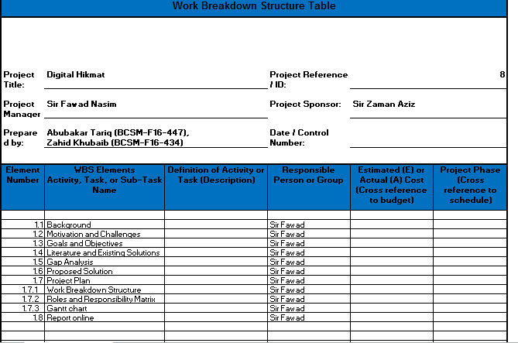

**Roles & Responsibility Matrix**

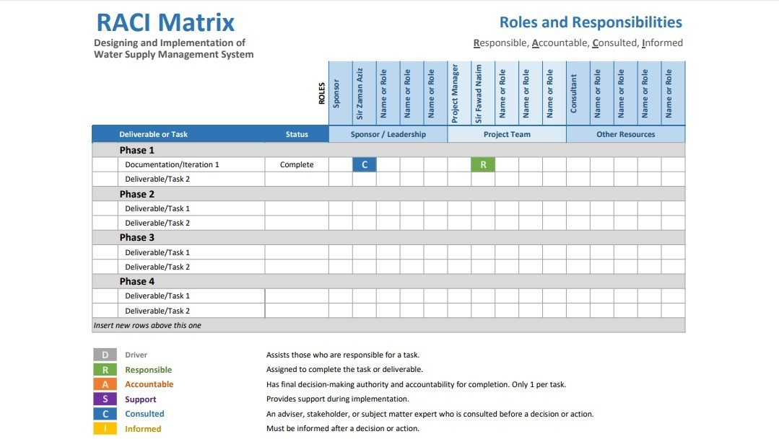

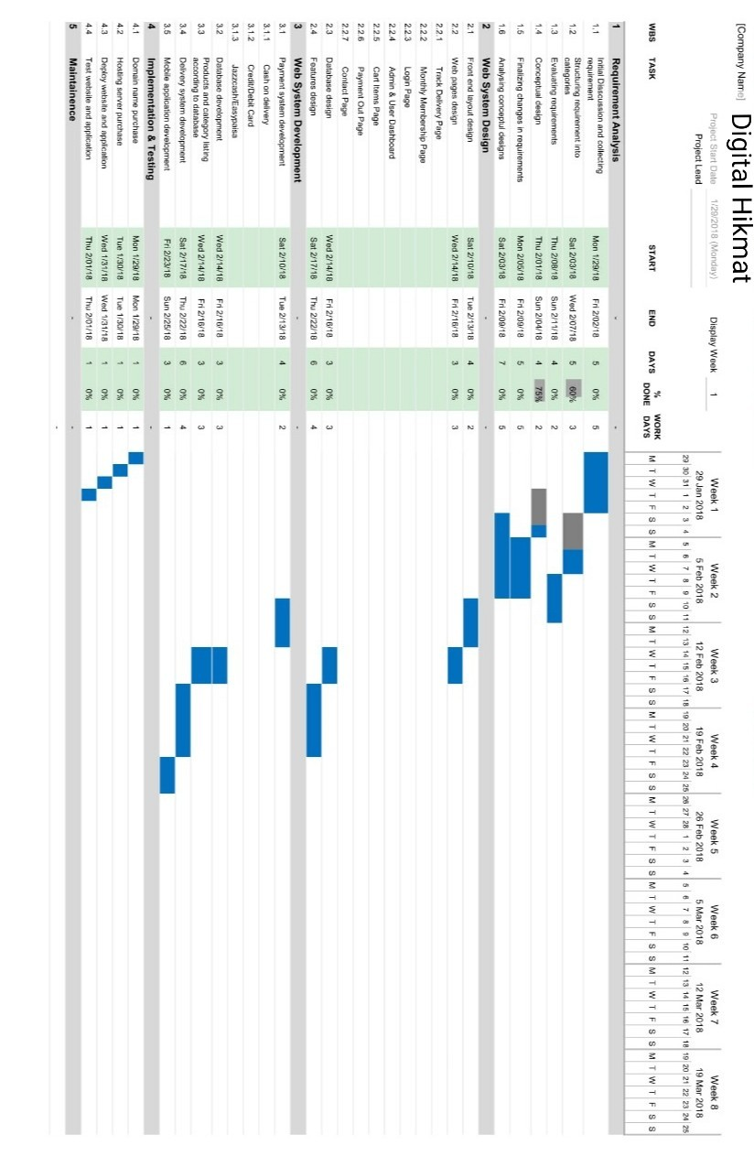

**Gantt C**

Project Report: < write Project title > here

**Report Outline**

A web based system to make the Hikmat technology oriented by offering a unique online website interface with easy understanding of people of all ages. This system provides easiness of getting Hikmat medicines at your doorstep; The patients have no need to visit Matab/ Hakeem for the treatment. They saw the symptoms of diseases on the website and also find the related medicines there. They also chat with the Hakeem and we also provide Online Hakeem

facility through video calling. Digital Hikmat fulfils the essential needs of patients and admin or Hakeem both. The Hakeem also manages the records or the medicines and the bills.

# Chapter 2

## Software Requirement

**Specifications**

**Chapter 2:** Software Requirement Specifications

#### Introduction

###### Purpose

* The purpose of Software Requirements Specification (SRS)document is to describe the external behavior of the United Builders management system.
* This will be and describes the operations, interfaces, performance and etc. of the United Builders management system.
* The document also describes the nonfunctional requirements of the system.
* The document also describes the design of the system.
* The document also describes the scope of the system such as development process and testing process.
* The document will also cover hardware, software, and various other technical dependencies

###### Document Conventions

This document explains every feature in details of the product. Each and every thing properly explains in this document. Headings and description has proper different

which is easy to understand to reader. This documentation write in easy and simple sentences which can be understand a normal person that know about English. Every requirement statement explains in proper way.

###### Intended Audience and Reading Suggestions

There should be different types of reader that read the document for understand and get the information about project. The reader may be such as developers, project managers, marketing staff, users, testers, and documentation writers that read the document.

The reader can get the brief information about the product by reading the introduction and get overall description about the product that is briefly describe in overall description portion

Readers who want to explore the features of system in more detail should read system features portion of the documents which fully explain all features of the products. The reader can be read user interface and hardware and software platforms on which the application can be run.

The reader can be read the non-technical behaviors of the system by the document such as performance, safety, security, and various other attributes that will be important to users. If the reader not found desired information than can be read other requirements.

###### Product Scope

This project’s aim is to create an online web based system which will help the patients and Matab/Hakeem by providing an easy to use interface. This system will assist the Matab/Hakeem in managing its customers/patients, medicines and their route bills. But more importantly our target is our Patients. We provide them online Hikmat facility with Digital

Hikmat. They have no need to visit the Matab/ Hakeem they saw the symptoms of diseases and their medicine in their home via Digital Hikmat website. Moreover we also provide the free

###### References

<List any other documents or Web addresses to which this SRS refers. These may include user interface style guides, contracts, standards, system requirements specifications, use case documents, or a vision and scope document. Provide enough information so that the reader could access a copy of each reference, including title, author, version number, date, and source or location.>

#### Overall Description

###### Product Perspective

<Describe the context and origin of the product being specified in this SRS. For example, state whether this product is a follow-on member of a product family, a replacement for certain existing systems, or a new, self-contained product. If the SRS defines a component of a larger system, relate the requirements of the larger system to the functionality of this software and identify interfaces between the two. A simple diagram that shows the major components of the overall system, subsystem interconnections, and external interfaces can be helpful.>

###### Product Functions

<Summarize the major functions the product must perform or must let the user perform. Details will be provided in Section 3, so only a high level summary (such as a bullet list)

is needed here. Organize the functions to make them understandable to any reader of the SRS. A

picture of the major groups of related requirements and how they relate, such as a top level data flow diagram or object class diagram, is often effective.>

###### User Classes and Characteristics

The product will be user friendly that is easy to use and faster and time saving. It has easy interface so there is no need of proper technical skills and experience for use of this product. There should not require of training for use this system. Anyone can be use this system easily that know about computer how to work. All the functions are properly work. The security level of this product is very high. The outsider cannot access data from this system. Each user can access only those functions which is allow to him.

###### Operating Environment

The main component of Tiles Mart is based on web form application and android form application both. In web form application, the performance of the product will be depend upon hardware

configuration

###### Design and Implementation Constraints

The product is a web based and android based both. User interface, color, resolution and screen size (height and width) has major effect on product design.

The speed of product is good. But the speed of the product also depends upon hardware

* ASP.NET
* Visual studio
* SQL server
* Bootstrap
* HTML
* CSS

###### User Documentation

The system is develop for digital hikmat . It is easy to use for user and its interface is very simple that is easy to understand for user.There should be make a document parallel with system developing. This document will be describe any features function of the product that will be properly gaud to user for product how to work and how run.

3 This website developer gave tutorial to online hakmet for understand the product. The tutorial step by step guide to user after installing the app how to work this system.

###### Assumptions and Dependencies

<List any assumed factors (as opposed to known facts) that could affect the requirements stated in the SRS. These could include third-party or commercial components that you plan to use, issues around the development or operating environment, or constraints. The project could be affected if these assumptions are incorrect, are not shared, or change. Also identify any dependencies the project has on external factors, such as software components that you intend to reuse from another project, unless they are already documented elsewhere (for example, in the vision and scope document or the project plan).>

#### External Interface Requirements

###### User Interfaces

<Describe the logical characteristics of each interface between the software product and the users. This may include sample screen images, any GUI standards or product family style guides that are to be followed, screen layout constraints, standard buttons and functions (e.g., help) that will appear on every screen, keyboard shortcuts, error message display standards, and so on. Define the software components for which a user interface is needed. Details of the user interface design should be documented in a separate user interface specification.>

###### Hardware Interfaces

<Describe the logical and physical characteristics of each interface between the software product and the hardware components of the system. This may include the supported device types, the nature of the data and control interactions between the software and the hardware, and communication protocols to be used.>

###### Software Interfaces

<Describe the connections between this product and other specific software components (name and version), including databases, operating systems, tools, libraries, and integrated

commercial components. Identify the data items or messages coming into the system and going out and describe the purpose of each. Describe the services needed and the nature of communications. Refer to documents that describe detailed application programming interface protocols. Identify data that will be shared across software components. If the data sharing mechanism must be implemented in a specific way (for example, use of a global data area in a multitasking operating system), specify this as an implementation constraint.>

###### Communications Interfaces

<Describe the requirements associated with any communications functions required by this product, including e-mail, web browser, network server communications protocols, electronic forms, and so on. Define any pertinent message formatting. Identify any communication standards that will be used, such as FTP or HTTP. Specify any communication security or encryption issues, data transfer rates, and synchronization mechanisms.>

#### System Features

<This template illustrates organizing the functional requirements for the product by system features, the major services provided by the product. You may prefer to organize this section by use case, mode of operation, user class, object class, functional hierarchy, or combinations of these, whatever makes the most logical sense for your product.>

###### System Feature 1

<Don’t really say “System Feature 1.” State the feature name in just a few words.>

Description and Priority

<Provide a short description of the feature and indicate whether it is of High, Medium, or Low priority. You could also include specific priority component ratings, such as benefit, penalty, cost, and risk (each rated on a relative scale from a low of 1 to a high of 9).>

Stimulus/Response Sequences

<List the sequences of user actions and system responses that stimulate the behavior defined for this feature. These will correspond to the dialog elements associated with use cases.>

Functional Requirements

REQ-SF1-1:Sign up/Registration. REQ-SF1-2:Login/Sign in.

REQ-SF1-3:View Categories. REQ-SF1-4:View Items.

REQ-SF1-5:Search Items. REQ-SF1-6:Place Order.

REQ-SF1-7:Cancel Order (Condition Applied). REQ-SF1-8:Select Quantity.

REQ-SF1-9:Confirm Order.

REQ-SF1-10:View Slider Image.

REQ-SF1-11:Check Stock Availability. REQ-SF1-12:Bill Generate.

* + 1. Web Application: -

REQ-SF1-1:Login/Sign In

REQ-SF1-2:Add Categories. REQ-SF1-3:View Categories.

REQ-SF1-4:Delete Categories. REQ-SF1-5:Add Items.

REQ-SF1-6:View Items.

REQ-SF1-7:Delete Items.

REQ-SF1-8:Search Items.

REQ-SF1-9:Check Stock Availability. REQ-SF1-10:Cancel Order.

REQ-SF1-11:Check Sale Details. REQ-SF1-12: Create Registration. REQ-SF1-13:Cancel Registration.

#### Other Nonfunctional Requirements

###### Performance Requirements

This website can smoothly run on any device but due to the additional Augmented Reality feature.

###### Safety Requirements

working on its ,once importance feature will be tested

###### Security Requirements

<Specify any requirements regarding security or privacy issues surrounding use of the product or protection of the data used or created by the product. Define any user identity authentication requirements. Refer to any external policies or regulations containing security issues that affect the product. Define any security or privacy certifications that must be satisfied.>

###### Software Quality Attributes

* + 1. **Software Quality Attributes**

Usability: -

This app is easy to use and easy to learn how to operate.

Portability: -

This app can be use on different devices like tablets, mobile phones.

Robustness: -

This app can handle many problems itself like if user forget his password then system gives it option to re-write name and user password.

Flexibility: -

The functionality of this app can be increased after the development of this app and documentation is available.

#### Other Requirements

The data of the product store on server side database. The data include the information about order, stock of material, generate bill, and financial report. The product is enough sufficient generate the bill and also automatically generate daily bases and monthly bases report that will be show profit and loss.

# Chapter 3

## Use Case Analysis

**Chapter 3:** System Analysis

#### Use Case Model



<<include>>

user name

password

<<include>>

login

admin

customer

appointment

<<extend>>

<<include>>

medicine<<include>>

category

disease



<<include>>

symptoms

home delivery

<<extend>>

<<include>>

order

hakeem

<<extend>>

manage appointemts

<<extend>>

delivery

change appoment

cancle appointment

send rminder

<<include>>

view all appointments

Login

custmore

login

admin

<<include>>

<<include>>

user name password

##### Registration

admin

Registration

<<include>>



<<include>>

compny name

<<include>>

create registration

<<include>>

cancle reg

<<include>>

<<include>>

<<include>>

<<include>>

username

user name

password re password

adress

* 1. **Use Case Specification**

###### Login to system: -

|  |  |
| --- | --- |
| ***ID:***  ***Brief***  ***Description: Actors:***  ***Preconditions: Main Flow: Post Condition:*** | **Login to System** |
| 1 |
| The user logs in in the system and user profile will be displayed. |
| custmore, admin |
| Internet connection must be established. |
| Enter username and password. |
| User object has created. |

***A***

|  |  |  |
| --- | --- | --- |
| ***lternativeflows:*** | Login fail, forget password and system down. |  |
|  |

###### Registration:

|  |  |
| --- | --- |
| ***ID:***  ***Brief***  ***Description: Actors:***  ***Preconditions: Main Flow: Post Condition:***  ***Alternativeflows:*** | **Registration** |
| 2 |
| admin created and cancel the account for user |
| Warehouse |
| Internet connection must be established. |
| Enter username and set password. |
| admin will able to create and cancel account to user. |
| Login fail/signup fail and system down. |

# Chapter 4

**System Design**

**Chapter 4:** System Design

[Paragraph Text 12 pt, Calibri, 1.5 Line Spacing, Justified] [*Between 4 to 8 lines describe what is this chapter all about*]

#### 4.1Architecture Diagram



#### 

#### 4.2Domain Model

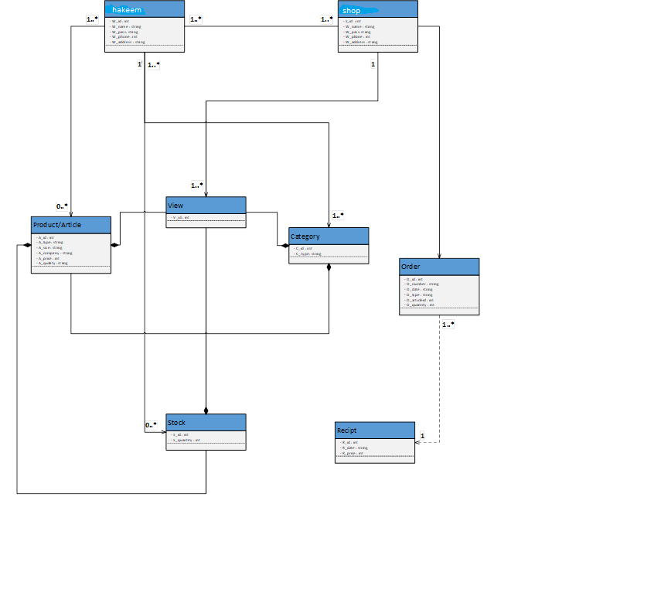

#### 4.3Entity Relationship Diagram with data dictionary

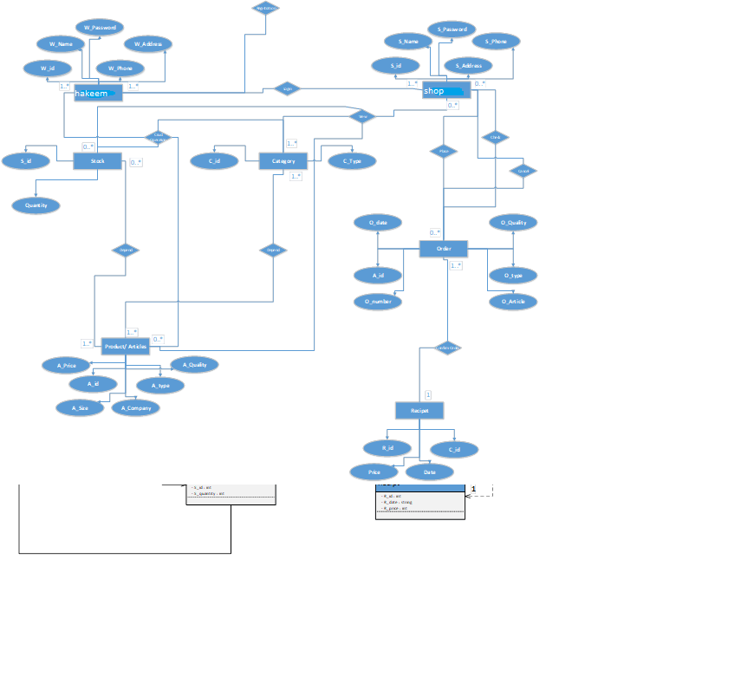

#### 

#### 4.4Class Diagram

#### 

#### 4.5Sequence / Collaboration Diagram

login:



**Registration:**



View article



**Order Detail:**



**Add Article:**



**Check stock:**



**Sale Detail:**



**Confirm Order:**



#### Operation contracts

#### Activity Diagram

**Login:**



**Registration:**



**Category:**



**Stock:**



**Order:**



**Receipt:**



**Full System Activity Diagram:**



#### State Transition Diagram

[Paragraph Text 12 pt, Calibri, 1.5 Line Spacing, Justified]

#### 4.7Component Diagram

#### 

#### Deployment Diagram

[Paragraph Text 12 pt, Calibri, 1.5 Line Spacing, Justified]

**4.7Data Flow diagram**

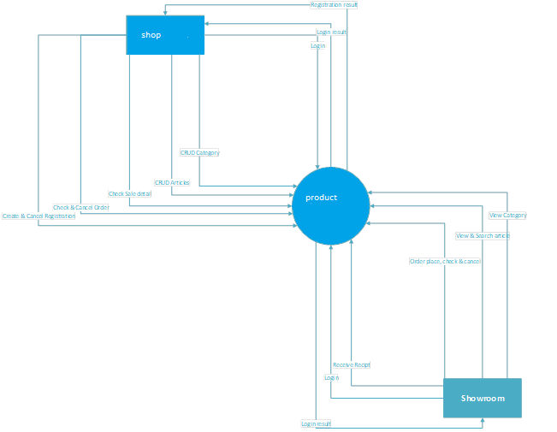

**Level 1:**



# Chapter 5

## Implementation

**Chapter 5:** Implementation

[Paragraph Text 12 pt, Calibri, 1.5 Line Spacing, Justified] [*Between 4 to 8 lines describe what is this chapter all about*]

#### Important Flow Control/Pseudo codes

[Paragraph Text 12 pt, Calibri, 1.5 Line Spacing, Justified]

#### Components, Libraries, Web Services and stubs

[Paragraph Text 12 pt, Calibri, 1.5 Line Spacing, Justified]

#### Deployment Environment

[Paragraph Text 12 pt, Calibri, 1.5 Line Spacing, Justified]

#### Tools and Techniques

[Paragraph Text 12 pt, Calibri, 1.5 Line Spacing, Justified]

#### Best Practices / Coding Standards

[Paragraph Text 12 pt, Calibri, 1.5 Line Spacing, Justified]

#### Version Control

[Paragraph Text 12 pt, Calibri, 1.5 Line Spacing, Justified]

# Appendices

**Appendix A:** Information / Promotional Material

[Paragraph Text 12 pt, Calibri, 1.5 Line Spacing, Justified] [*Between 4 to 8 lines describe what is this appendix all about*]

#### Broacher

**Flyer**

**Standee**

**Banner**

**First Level heading [16 pt, Calibri, Bold, Left aligned]**

[Paragraph Text 12 pt, Calibri, 1.5 Line Spacing, Justified]

###### Second level heading [14 pt, Calibri, Bold, Left aligned]

[Paragraph Text 12 pt, Calibri, 1.5 Line Spacing, Justified]

###### Third level heading [12 pt, Calibri, Bold, Left aligned]

[Paragraph Text 12 pt, Calibri, 1.5 Line Spacing, Justified]

**Appendix [no.]:** Appendix Title

[Paragraph Text 12 pt, Calibri, 1.5 Line Spacing, Justified] [*Between 4 to 8 lines describe what is this chapter all about*]

#### First Level heading [16 pt, Calibri, Bold, Left aligned]

[Paragraph Text 12 pt, Calibri, 1.5 Line Spacing, Justified]

###### Second level heading [14 pt, Calibri, Bold, Left aligned]

[Paragraph Text 12 pt, Calibri, 1.5 Line Spacing, Justified]

###### Third level heading [12 pt, Calibri, Bold, Left aligned]

[Paragraph Text 12 pt, Calibri, 1.5 Line Spacing, Justified]

# Reference

and Bibliograph y

### Reference and Bibliography

* + 1. M. Sher, M. Rehman, “*Title of the Paper*” Conference name/Journal Name, Edition, Volume, Issue, ISBN/ISSN, PP, Publisher/City-Country, Year.

[2] ……

# Index

### Index

[A]

**[B]**

**[C]**